- No more than 4 Heater Strips per Transformer

- Do not install product where you expect standing water

- Do not directly connect into 120 VAC

- Do not penetrate or puncture material with metal objects

- Do not exceed minimum (3 Ft) and maximum (12-14 Ft) material lengths

- Do not exceed 30ft-wiring limitation on Secondary Circuit

- Do not place transformer within 4 inches of combustible materials

- Always use 10 AWG between Transformer and Heater Strip

✗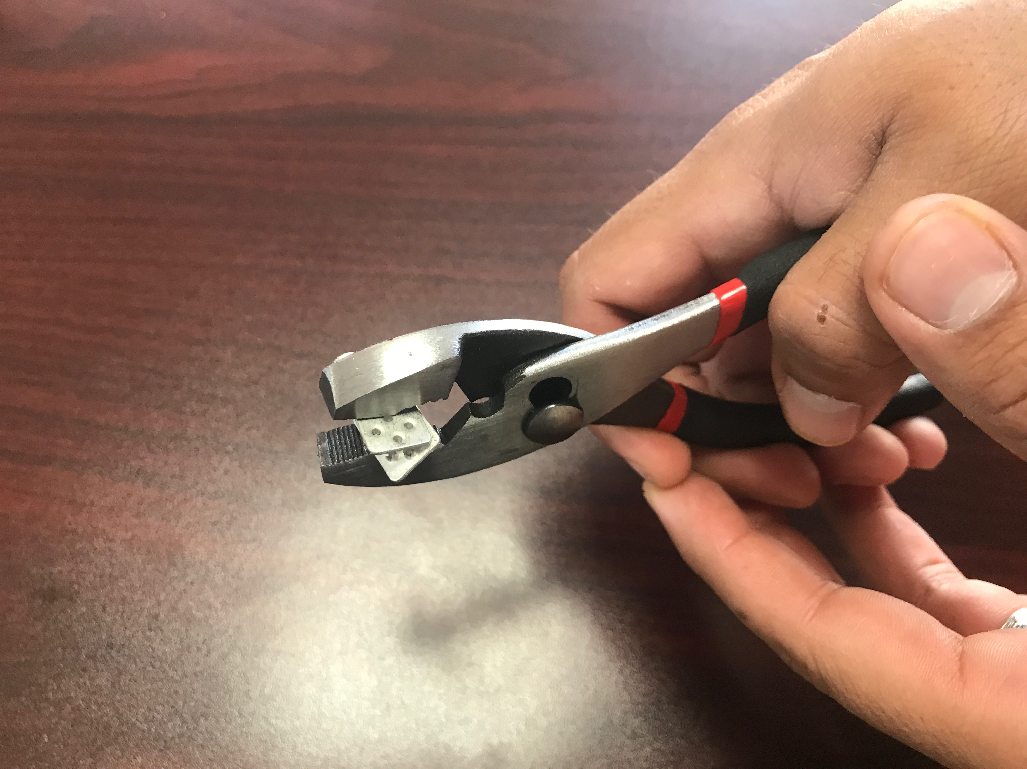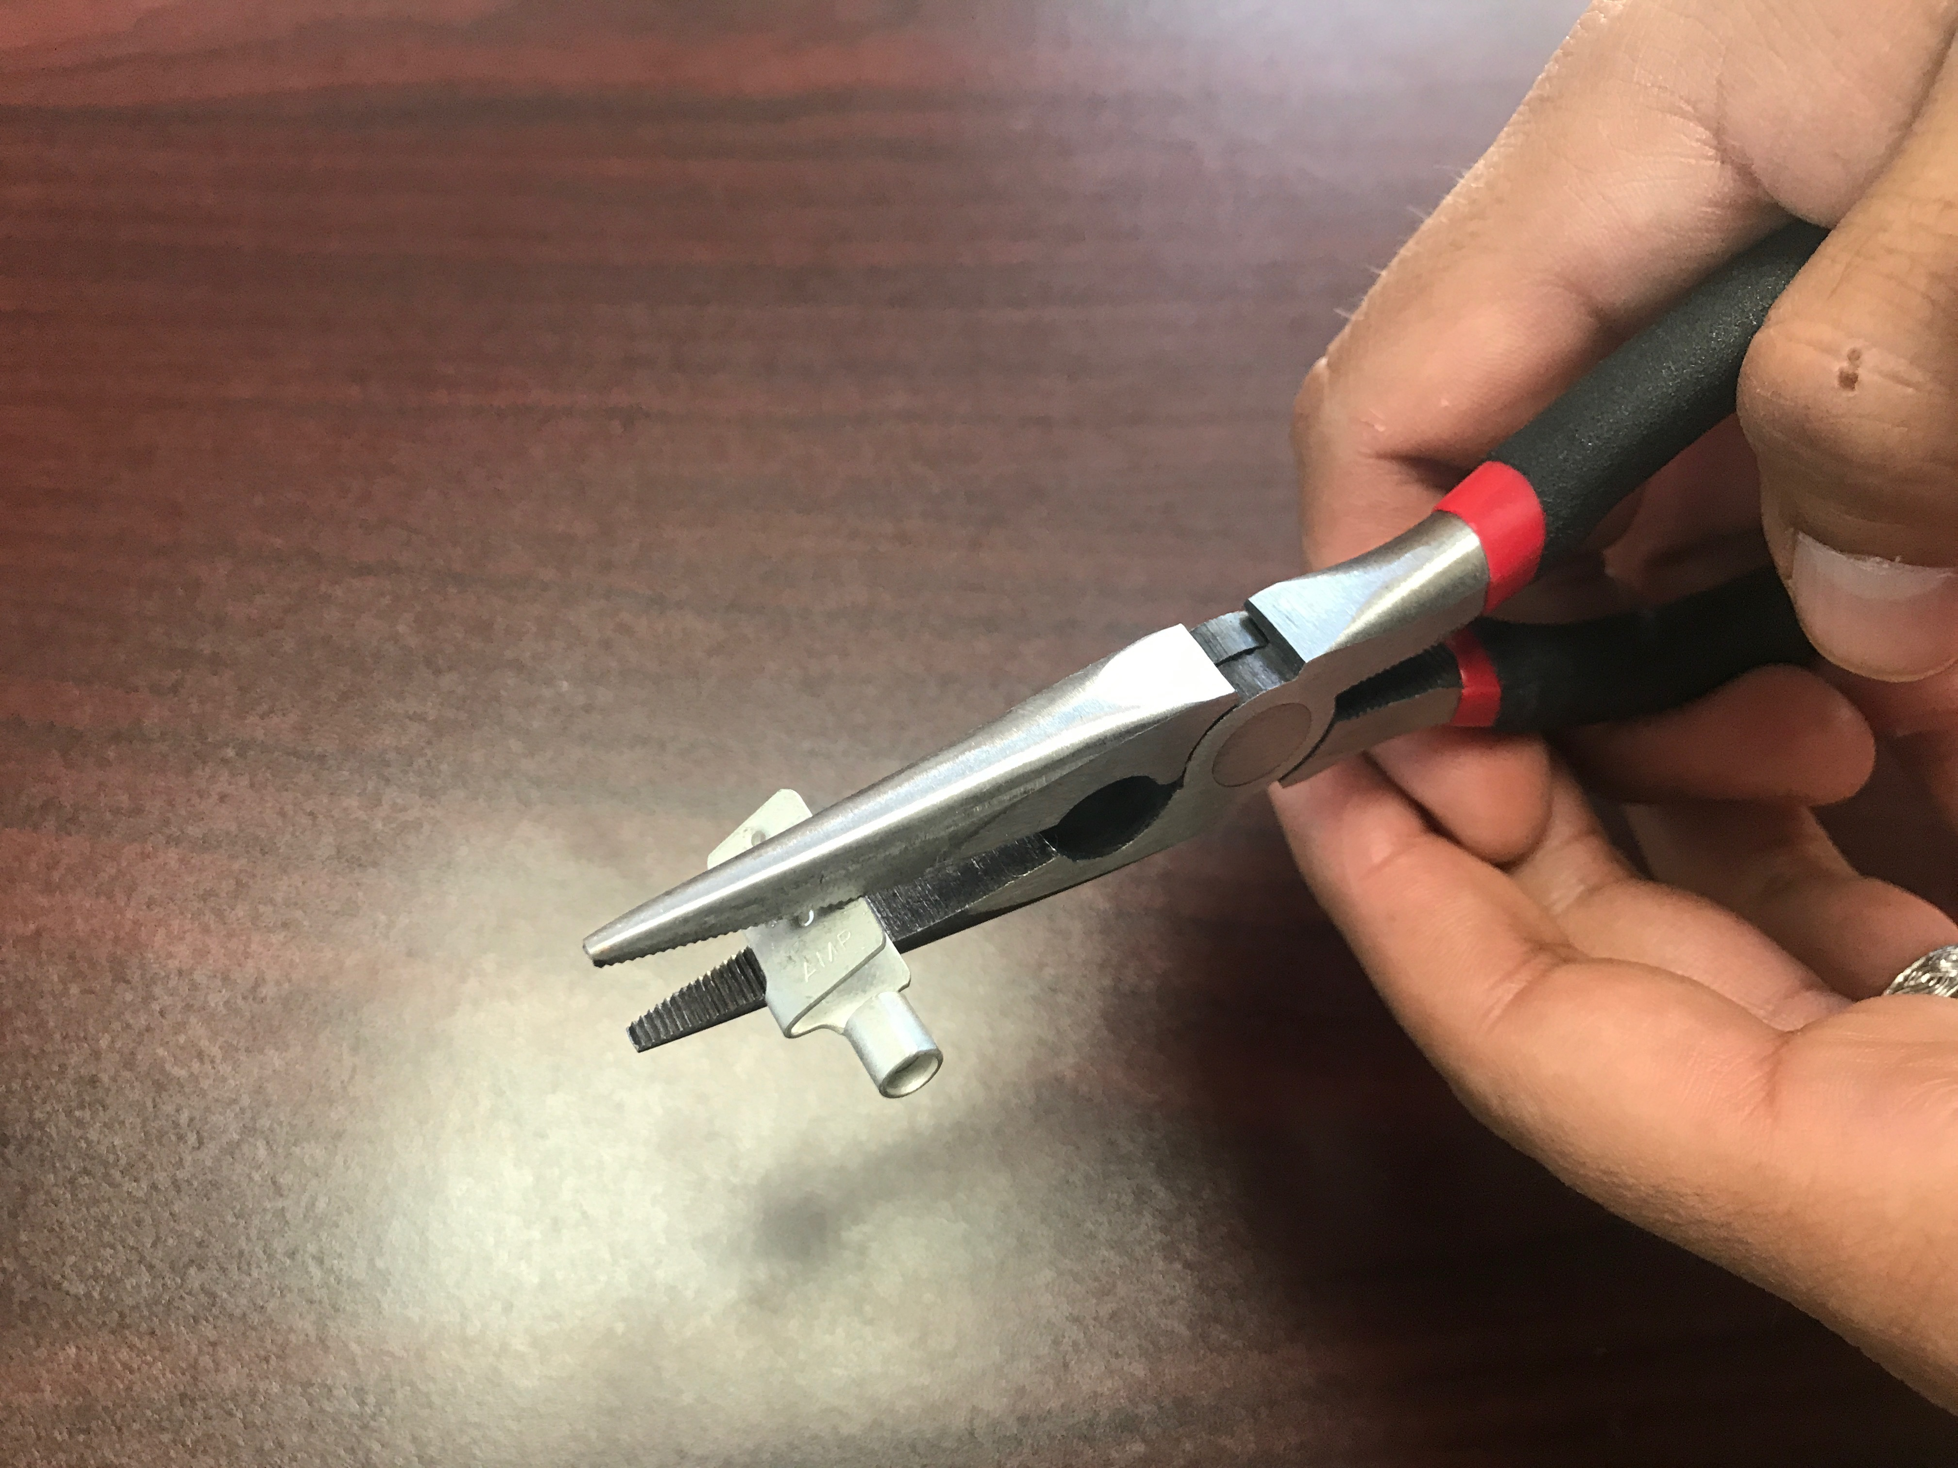
Do not use Linesman, needlenose or any other type of pliers to secure Splice Connector onto material!
✓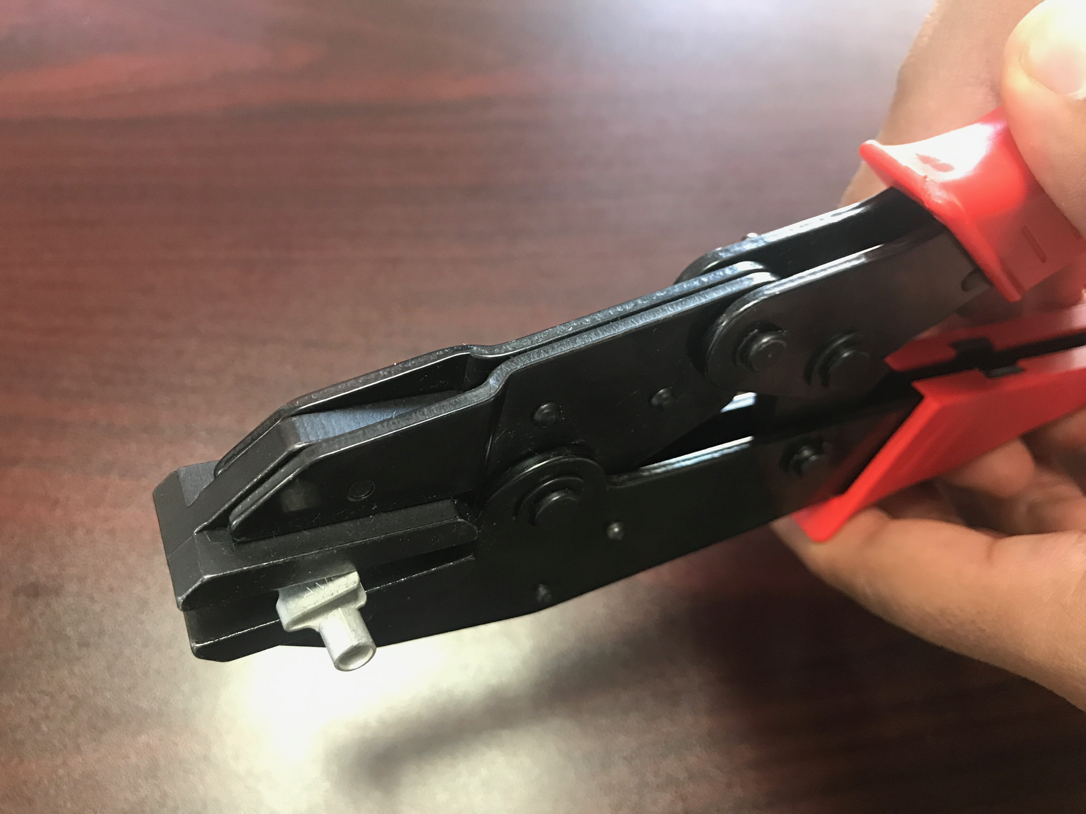
For proper crimping please use a flat nose-crimping tool!
✗

